**Photographs:**

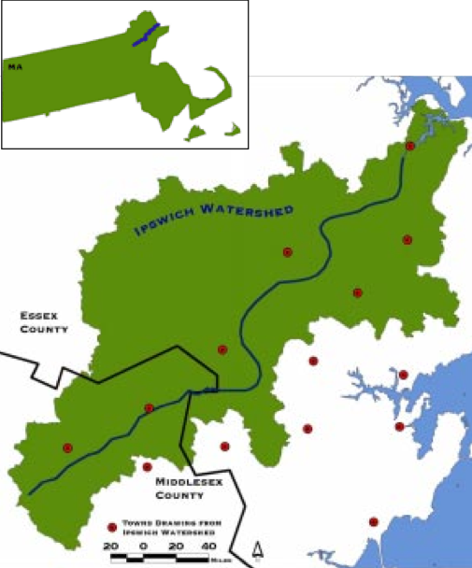

"Ipswich River Watershed." Web. 10 Oct 2010. <http://act.americanrivers.org/site/DocServer/meripswich.pdf?docID=676>.



"Ipswich River Map." Web. 10 Oct 2010. <http://www.northreadingma.gov/Pages/NReadingMA_Water/00FF6E72- 000F8513.5/Ipswich%20River%20Watershed.gif>.



"Nitrogen Cycle." Web. 19 Oct 2010. <http://www.windows2universe.org/earth/climate/images/nitrogencycle.jpg>.



"How Wetlands Work." Web. 19 Oct 2010. <http://greenerloudoun.files.wordpress.com/2008/02/how-wetlands-work.jpg>.

**More Citations:**

"Habitats of the Acec." State of Massachusetts, n.d. Web. 10 Oct 2010. <http://www.mass.gov/czm/prebresourcehabitats.pdf>.

"Ipswich River." Ipswich River Watershed Association. Ipswich River Watershed Association, Web. 10 Oct 2010.

<http://ipswichriver.org/>.

Liles, George. "Another Reason to Keep the Wetlands Wet." Ipswich River. Marine Biological Laboratory, Web. 10 Oct 2010. <http://www.mbl.edu/publications/pub_archive/labnotes/7.2/wetlands.html>.

"Plants of the Ipswich River." Ipswich River Watershed Biodiversity. Web. 10 Oct 2010.

<http://web.mac.com/jm3/Ipswich_River_Nature/Plants.html>.

"State of the River 2003." Ipswich River. Ipswich River Watershed Association, 2003. Web. 10 Oct 2010.

<http://ipswich-river.org/wp-content/uploads/2010/03/StateoftheRiver2003.pdf>.

"Tour of the Ipswich River Watershed." Ipswich River: Tour the Watershed. Web. 10 Oct 2010.

<http://ipswichriver.org/about-the-river/tour-the-watershed/>.