7. "Silver Maple Leaf." Web. 19 Oct 2010. <http://www.troop17.com/Tree_Identification/maple_silver_72dpi.jpg>.

"Silver Maple Tree." Web. 19 Oct 2010.

<http://www.andersonseedandgarden.com/store/product_images/396.jpg>.

"Silver Maple." Plant Guide. Natural Resources Conservation Service, Web. 10 Oct 2010.

<http://plants.usda.gov/plantguide/pdf/pg_acsa2.pdf>.

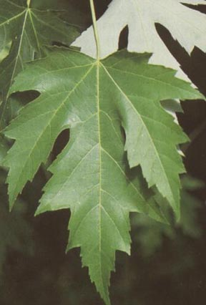

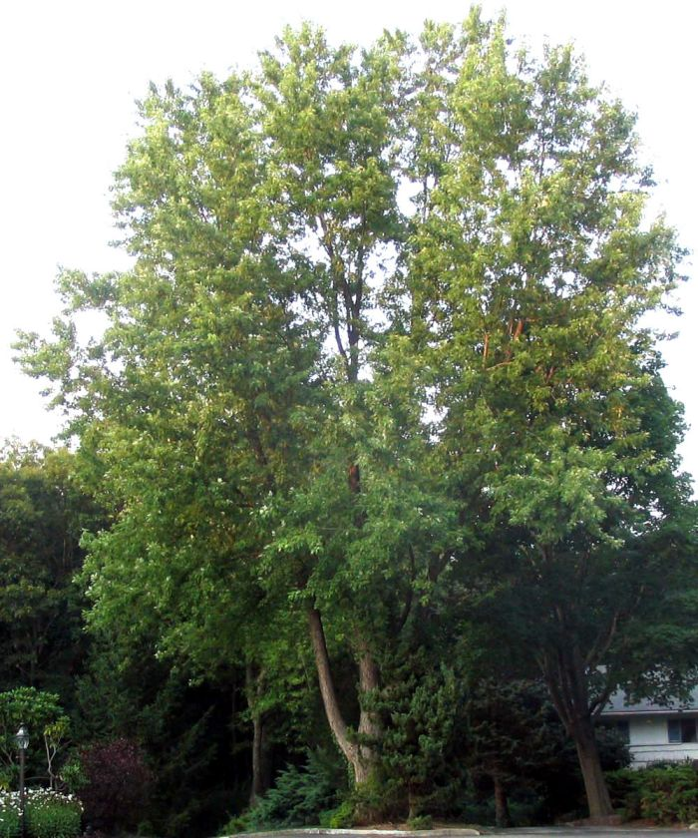

The Silver Maple (*Acer saccharinum* L.) floodplain forest in the Ipswich River watershed displays the specie’s ability to adjust to different water levels. With raised roots, these trees are able to survive flooding without drowning its root system. The sap of the Silver Maple, or the water maple, has the lowest sugar content of the maple species that is used for syrup. However, it has been used for kidney and liver ailments, cough syrup, and is popularly used for furniture and sold as “soft maple” with its relative, the Red Maple. Its seeds are eaten by birds, the buds by squirrels, the bark by beavers, and its foliage by deer and rabbits.

8. "Highbush Blueberry Shrub." Web. 19 Oct 2010. <http://3.bp.blogspot.com/_HuOShmQVWWs/SPzB64TxAPI/AAAAAAAAAtg/zv8nsnLmToQ/s400/blueberry+fall.jpg>.

"Highbush Blueberry." Web. 19 Oct 2010. <http://www.talltreesgroup.com/Vaccinium%20corymbosum.jpg>.

"Highbush Blueberry." Plant Fact Sheet. Natural Resources Conservation Service. Web. 10 Oct 2010.

<http://plants.usda.gov/factsheet/pdf/fs_vaco.pdf>.



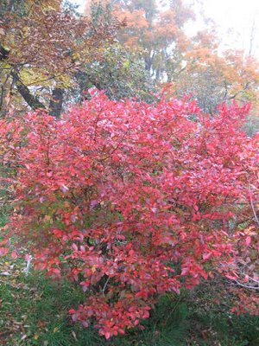

Highbush Blueberry (*Vaccinium corymbosum* L.) are also found throughout the watershed. Blueberries provide summer and early fall food to a variety of birds and mammals, including humans. Moist or wet habitats such as marshes, swamps, and flood-prone areas provide the best homes. However, Highbush Blueberries can also exist in drier areas such as dunes and barrier beaches.