Title: Muck or Magic?
Question: What is the Great Wenham Swamp?
The Great Wenham Swamp is called “great” for a reason. It is the largest freshwater marsh in the North Shore area, spanning over 2,500 acres in Topsfield, Wenham and Hamilton- most of which falls within the boundaries of the Ipswich River Wildlife Sanctuary. Although some believe that swamps are nothing more than large masses of mud, The Great Wenham Swamp is actually comprised of a variety of ecotones, in which many different plant and animal species thrive. Perhaps the most prevalent of these ecotones is the Silver Maple floodplain forest. These forests are especially rare because most of them were cleared for farmland in the 1700s and 1800s, since the moist soil is so fertile.
This fertility is caused by the constant shifting of soil due to seasonal flooding. Water that covers the floodplain often comes from the upstream Ipswich River, which contains sediment that is rich in minerals and nutrients. This nourishing, alluvial soil is carried into the floodplain during the flood and is deposited when the water recedes, leaving a perfect bed of fertilizer for new plants and saplings to thrive in.

Some fun facts...
- Almost all of the GWS falls within the boundaries of the Ipswich River Wildlife Society. Luckily, the small portion that is outside of these boundaries falls into Bradley Palmer State Park, which also works to protect it.
- Water in the GWS is actually some of the cleanest in the area, because the cattails and other marsh plants are able to soak up and break down pollutants and toxins.
- Using the Ipswich River and GWS as a water source is crucial to the town of Ipswich, because otherwise the river could overflow during heavy rainfall and flood the entire area. However, a total of 19 communities get their water from the Ipswich River and Great Wenham Swamp, which drains the water before it can replenish itself. This causes incredible damage to the river ecosystem, and is the reason why voluntary water bans can start as early as April.
- Most of the GWS is generally inaccessible to people, even with a canoe. However, the Ipswich River Wildlife Sanctuary has put up directional flags to prevent canoeists from getting lost in the portions that are accessible.
- The GWS is a perfect habitat for the rare river otter, which makes its home only in habitats that feature a variety of ecotones. In recent years, beavers and muskrats have also made a comeback, and their dams help with water retention.
- In 1999, the water level in the river and the GWS were so low that all of the water in Bunker Meadows dried up, causing a feeding frenzy among Great Blue Herons trying to get at the fish and frogs that were dying. This drought also brought about the invasion of phragmites (see invasive species chart).
- In 1917, the Salem Beverly Waterway Canal (also known as the Great Wenham Canal) was built through the swamp in order to bring water to nearby residents and restore the Wenham Lake, which had deteriorated from pollution and overuse.
- In recent years, wild rice has been found growing in some exterior parts of the GWS. It has attracted a variety of duck species to the area, and preservationists have begun to wonder if it was planted by duck hunters for this purpose. However, it has not been harmful to the environment, and is not only edible for ducks but for humans as well.
- As for the exact boundaries of the GWS, experts have mixed opinions. Though the main mass of it is Southwest of the Ipswich River Wildlife Sanctuary trails, some say that it extends North as far as the marshland surrounding Pine Island, and the Ipswich River itself, while others say it reaches no further than the South Esker Trail. To the West, some say it extends into Bunker Meadow and even as far as Perkins Row. Yet another opinion is that all of the marshland surrounding the Ipswich River Wildlife Sanctuary is all one mass, and that is the reason the borders between the officially named sites are blurred.

Words to Know:
- Alluvial – Regarding sediment deposited by flowing water, as in a riverbed, flood plain, or delta.
- Biome – An environment determined by temperature and precipitation, i.e. forest, desert, tundra.
- Coniferous – A type of tree that has narrow “needles” that stay on the trees through the winter.
- Deciduous – A type of tree that has broad leaves that turn color and fall off at the end of autumn.
- Ecotone – The “blurred” portion between two distinct biomes, i.e. the transition between forest and grassland
- Esker – A ridge made of sediment deposits left by a traveling, melting glacier.
- Exotic – In this case, a species that comes from a different environment than the one it currently resides in.
- Floodplain forest – Wetlands characterized by peat bogs and plentiful, thriving foliage. They are seasonally flooded and the ground is covered in water for a few months every year. This allows many types of foliage to grow in the moist, nutrient-rich soil.
- Hydromorphic soil – Soil that usually carries an excess of water. This is a key characteristic of the floodplain forest.
- IBA – Important Bird Areas. Usually the criteria for deciding an IBA involves: a high number of endangered or threatened bird species residing in an area, a high concentration of many bird species during migration or mating season, a biome or ecotone that is unique, rare, or endangered, or a habitat that requires funding to study, preserve, and research.
- Native – In this case, a species that originated in the environment that it currently resides in.

The variety of trees that are able to survive in the fertile soil of the Great Wenham Swamp are a key factor in the survival of the many species of mammals, birds, insects, and other creatures that live there. Below is a list of the most commonly found trees in the GWS.
 | Swamp White Oak | The Swamp White Oak grows best in the hydromorphic soil offered by the GWS, although it does not survive well in soil that is flooded all year long. Its autumn colors are less vibrant than the Silver or Red Maple, but it is almost as common.
 | Red Maple | The red maple is one of the trees responsible for the amazing colors that cover the GWS during the autumn. It also provides a stable home for many migrating birds, and is also particularly favored by the Yellow Warbler during the springtime mating season.
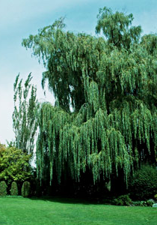 | Willow | Willows are not as common as other trees in the GWS, though it is not due to their inability to reproduce. A Willow tree can sprout from anything as small as a broken twig that was carried away by a bird. The seeds are also very lightweight, which allows them to be carried away by the wind. More Willows are being deliberately planted in the area, because their roots are very good at cleaning the water that passes through them, making the tree a kind of natural filter.
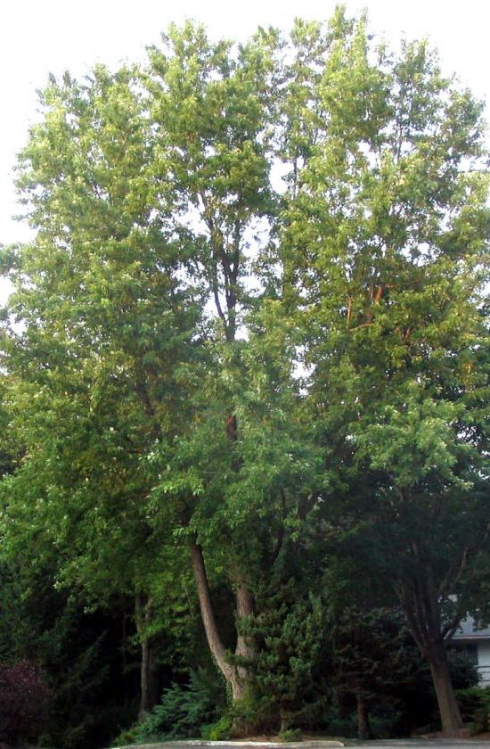 | Silver Maple | The Silver Maple makes up the majority of the deciduous foliage found in the GWS floodplain forests. Although it requires more sunlight than other tree species, it is also highly adaptable and can thrive in the constant moisture of the floodplain. It is also very resistant to ecological disasters, and can re-grow very quickly after forest fires or heavy storms.
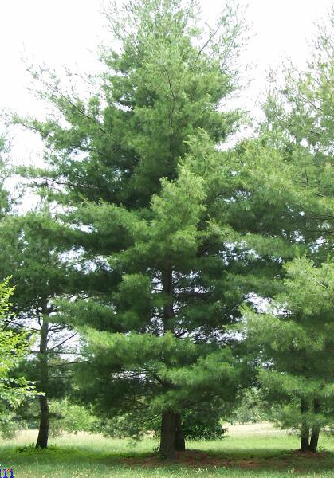 | White Pine | The White Pine is the most commonly found coniferous tree in the GWS, and is generally a blue-green color with narrow cones. It is almost always the tallest tree in the forest, and can survive in most environments, including the boggy terrain of the GWS.
All pictures and additional information from http://www.cirrusimage.com/trees.htm

The diverse and rich habitat provided by the Great Wenham Swamp is crucial to the survival of many birds in the area, as well as other birds that pass over the area during migration. In particular, the GWS has been named an Important Bird Area (IBA) by the National Audubon Society, which means that it is responsible for the identification and conservation of the birds that pass through. The GWS is part of a combination of habitats that forms the 7,229 acre Eastern Essex County Interior Forest IBA.
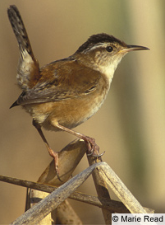 | Marsh Wren | Marsh Wrens are weavers, which means that they make intricate, basket-like nests in which to breed. Usually males make the nests out of cattails, and an impressed female will then line it with the cattail “fuzz”. A skilled male can make multiple nests in order to attract multiple mates at a time.
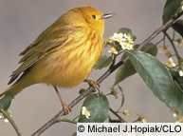 | Yellow Warbler | Yellow Warblers are the most brightly-colored of any warbler species. They prefer the GWS because of the abundant red maples.
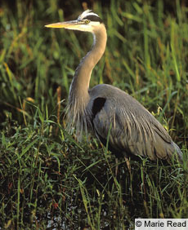 | Great Blue Heron | The Great Blue Heron is the largest heron in North America, with a wingspan of up to six feet. The GWS floodplains are perfect for nesting, since the moist soil makes for easy nest building, and the lack of human disruption encourages mating and brood health.
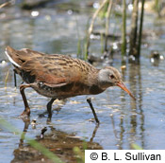 | Virginia Rail | The Virginia Rail is one of the many migratory birds that stop to rest in the GWS. In fact, the GWS makes many migrations possible by offering food, shelter and water all in one place; something that is difficult to come by during the long journey.
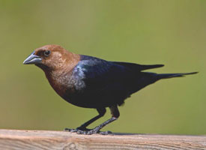  © ashockenberry | Brown-headed Cowbird | One of the invasive bird species in the GWS, the Cowbird lays up to three dozen eggs in various host nests. Often the cowbird chicks outcompete the chicks native to the nest, so that the native chicks sometimes starve and die.
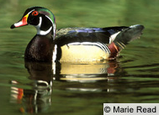 | Wood Duck | The GWS is most likely the best habitat for Wood Ducks in the entire state, since they need both open water and trees in which to nest in. (It is one of the few North American ducks that nest in trees.)
 | American Woodcocks | Another bird that requires the environmental diversity of the GWS is the American Woodcock. They need the soft soil of the floodplain to dig their nests, and the water in the floodplain to breed and collect food.
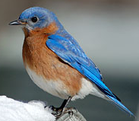  © Beth Donald | Eastern Bluebird | Bluebird have in recent years become more and more difficult to find in the wild- without a manmade ‘bluebird house’. However, the vast resources and diverse environment of the GWS attract Bluebirds naturally.
All pictures and additional information from http//:www.allaboutbirds.org

An invasive species is any plant, animal, or other living thing that is not native to the environment it is currently surviving in. Unfortunately, invasive species are often better adapted to the environment than the native species are, and are successful in outcompeting them. Examples of invasive species are plants that either take up space without providing food or effectively strangle other species fighting for the same light source. Although such plants are harmful to the ecological stability of the environment, it is very difficult to remove them once they have infiltrated. Preservationists are currently using careful application of pesticides and predatory species (see Purple Loosestrife).
The following is a list of invasive plant species, but creatures such as the Cowbird can also pose a threat to native species.
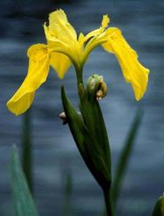  ©John M. Randall | Yellow Iris | Although very pretty, Yellow Iris takes up space and nutrients without providing anything useful such as edible seeds, petals, or roots.
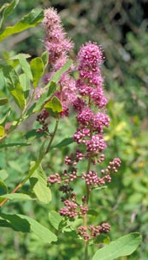  ©Linda Wilson | Purple Loosestrife | Another pretty species, Purple Loosestrife began killing native species so quickly that preservationists introduced an exotic beetle to eat it. Currently, the two populations cyclically fluctuate in accordance with each other, since the beetles prefer the Loosestrife fairly exclusively.
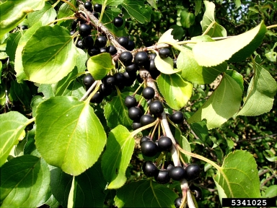  ©Jan Samanek | European Buckthorn Shrub | European Buckthorn Shrubs usually appear on banks along which canoeists travel. This is because the seeds often float in the water and are then dragged up onto the bank when they attach to the sides of a canoe.
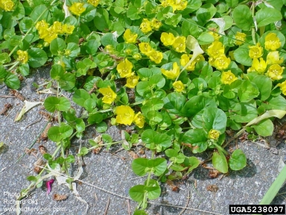  ©Richard Old | Moneywort | Moneywort grows along the forest floor, and often chokes young tree saplings and other low-lying sprouts.
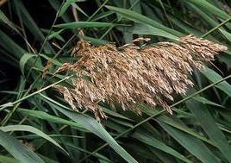  ©Joseph M. DiTomaso | Phragmites (Common Reed) | Often seen along the highway, Phragmites kills native species in the GWS as well, since it thrives in the damp soil. It is thought to have originated in the American south, but it appeared here after a drought in the late 1990s.
All pictures and additional information from http://www.invasive .org

For further information, or for a look at the Great Wenham Swamp in person, check out:
The Ipswich River Wildlife Sanctuary
87 Perkins Row
Topsfield, MA 01983
The trails are open from dawn until dusk on Tuesdays through Sunday, and the Nature Center and Office are open from 9AM to 4PM. Make sure to check out their trail map at: http://www.massaudubon.org/Nature_Connection/Sanctuaries/images/maps/ipswich_trails.gif

Works Cited

- All About Birds. Web. 26 Nov. 2010. <http://www.allaboutbirds.org/>.
- "Alluvial - Definition, Synonyms, Pronunciation, Spelling from Free Dictionary." Free Dictionary. Web. 01 Dec. 2010. <http://freedictionary.org/?Query=alluvial>.
- "Audubon: Birds & Science." National Audubon Society. Web. 06 Dec. 2010. <http://web4.audubon.org/bird/iba/criteria.html>.
- Decker, Carol. "The Great Wenham Swamp." Personal interview. 3 Nov. 2010.
- "Forest Definition of Forest in the Free Online Encyclopedia." Encyclopedia. Web. 05 Dec. 2010. <http://encyclopedia2.thefreedictionary.com/Forest>.
- "IBA Program | Mass Audubon." Welcome to Mass Audubon! 2010. Web. 04 Nov. 2010. <http://www.massaudubon.org/Birds_and_Birding/IBAs/>.
- "IBA Program | Mass Audubon." Welcome to Mass Audubon! Web. 04 Nov. 2010. <http://www.massaudubon.org/Birds_and_Birding/IBAs/site_summary.php?getsite=56>.
- "Invasive Species | National Audubon Society Policy Issues & Action." Policy Issues & Action | National Audubon Society Policy Issues & Action. Web. 06 Dec. 2010. <http://policy.audubon.org/invasive-species>.
- Invasive Species: Information, Images, Videos, Distribution Maps. Web. 17 Nov. 2010. <http://www.invasive.org/>.
- "Ipswich River | Mass Audubon | Nature Connection." Welcome to Mass Audubon! Web. 06 Dec. 2010. <http://www.massaudubon.org/Nature_Connection/Sanctuaries/Ipswich_River/index.php>.
- "Ipswich River Wildlife Sanctuary." Mass Audubon. Web. 5 Dec. 2010. <http://www.massaudubon.org/Nature_Connection/Sanctuaries/images/maps/ipswich_trails.gif>.
- Middleton Stream Team. "Wild Rice Revisited." Ipswich River Watershed Association. Web. 5 Dec. 2010. <http://ipswichriver.org/2010/09/the-water-closet-sept-13-2010/#more-2390>.

