**A Bird’s Eye View**

What are the common bird species that reside in the Ipswich River Watershed?

By: Ellie DiBenedetto

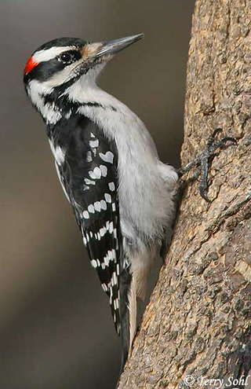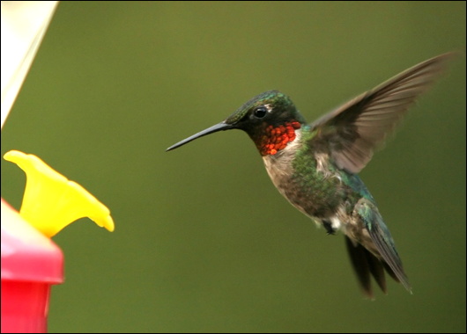

Ruby-Throated Hummingbird

**Seasons**: Summer; mid- spring

**Migration**: They migrate towards Central America, the Caribbean, and Mexico during the fall and winter seasons due to drastic weather drops and a lack of resources.

**Nesting**: The mother lays two white eggs two or three days apart. The mother will incubate from 60 to 80 percent of the day for 12-16 days. Depending on food availability; 18-23 days is a normal cycle amount. When they leave the nest, the chicks are considerably larger than their mothers.

Hairy Woodpecker

**Seasons**: Winter; Summer; Fall; Spring.

**Migration**: Live in river habitat all year long.

**Nesting**: These birds dig up a cavity in live wood. Both male and female incubate 3 to 6 eggs. Males brood the eggs at night, and females during the day. Eggs hatch in approximately two weeks. Young birds will stay with their parents for the first two weeks or so before they become independent.

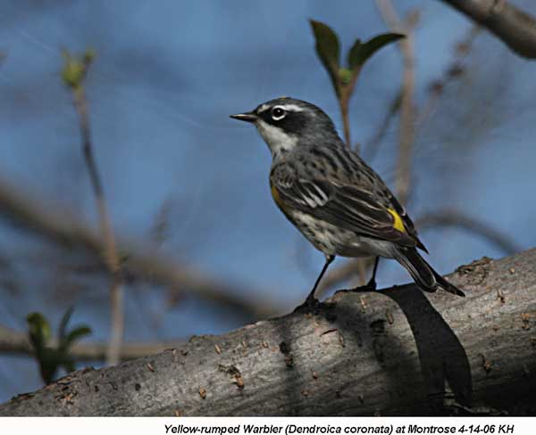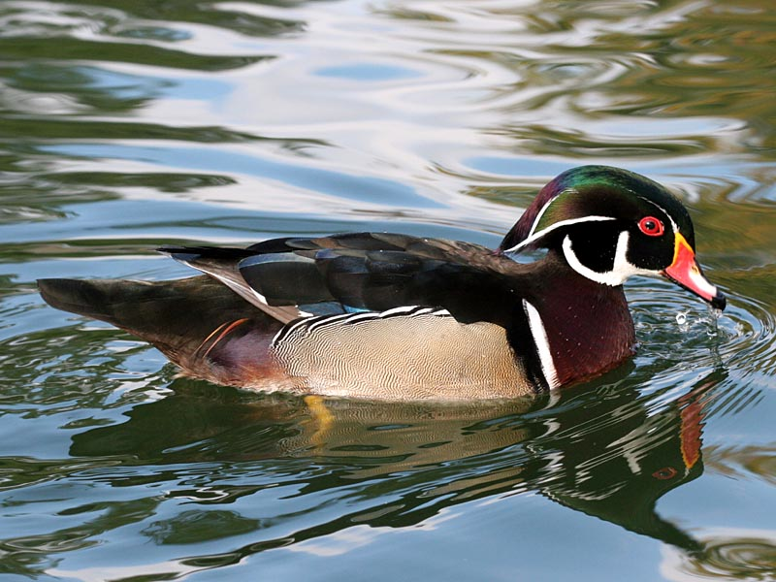

Yellow- Rumped Warbler

**Seasons**: Spring; Fall; Summer

**Migration**: Last flock of warblers to leave northeast and head to warmer locations such as Washington. Known to fall between short and medium- distance migrants.

**Nesting**: Males arrive on the breeding grounds a few days before the females. The female builds the nest; a small, flat cup of twigs, grass, moss, and rootlets, lined with plant down and feathers that curve over the rim of the nest, partially covering the eggs. The female incubates 4 to 5 eggs for 12 to 13 days. The young leave the nest between 10 to 14 days.

Wood Duck

**Seasons**: Spring; Summer; Fall; Winter.

**Migration**: Short-distance migrants. Travel locally to the closest open body of water.

**Nesting**: Wood Ducks nest in cavities near or above water. The cavity is lined with down. The female lays 9 to 14 eggs and incubates them up to 35 days. After, the pair breaks up. After one day in the nest, the young leap to the ground or water. The female continues to tend them for 5 to 6 weeks and leaves them before they can fly.

Tree Swallow

**Seasons**: Spring; Summer

**Migration**: They migrate to Central/ South America, huddle for warmth at night, and fly individually during the day.

**Nesting**: They nest in cavities; nests are located singly or in loose colonies. The male brings nesting material to the female, and she creates the nest. The nest is a cup of grass, weeds, and other plant material, lined with feathers. The female incubates 4 to 7 eggs for 14 to 15 days. Young leave the nest at 18 to 22 days.

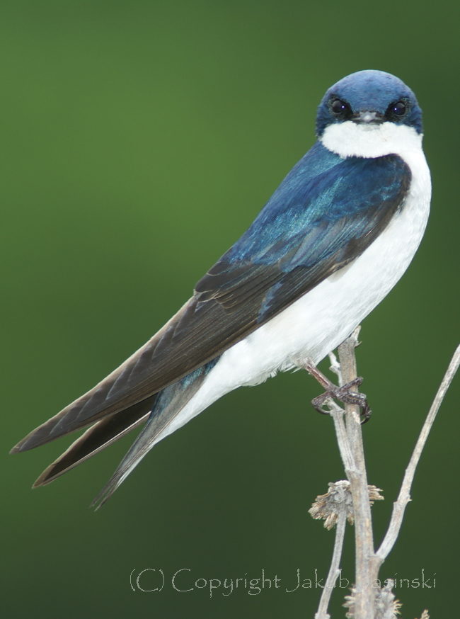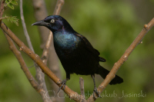

Common Grackle

**Seasons**: Summer; Spring; Fall; Winter.

**Migration**: Short- distance migrant. Stays local, but heads toward southern part of breeding range.

**Nesting**: The nest is made of grass, twigs, and mud. The nest is located in a shrub or tree up to 30 feet above the water. The female will lay 4 to 7 eggs that are pale greenish brown. Incubation of the eggs will last about 13 to 14 days with the young leaving the nest in about 12 to 16 days after hatching. During this time the male Grackle may guard the nest while the female feeds.

Canada Goose

**Seasons**: Spring; Summer; Winter; Fall

**Migration**: Past generations used to follow a rigid migration pattern to travel to Washington and warmer states. Today, most Canada Geese are found to be year round residents.

**Nesting**: The female creates the nest with sticks, grass, weeds and down in a place that is slightly elevated and away from the water. She lays and incubates between 4 to 7 eggs, while the male stands guard nearby. Incubation lasts about twenty-eight days. Once hatched, the young leave the nest within 1 to 2 days. Young are able to fly within 7 to 9 weeks after hatching and stay with their parents for the first year.

Mourning Dove

**Seasons**: Spring; Summer.

**Migration**: Head to southern states during colder weather. Leave mid October and return late march.

**Nesting**: Nests are usually located in a tree or shrub, but may be found on the ground, on a building ledge, or other structure. The female chooses the location. There, she lays 2 eggs, and both parents incubate for 2 weeks. Both males and females produce "pigeon milk," a protein- and fat-rich liquid, which they feed to their young. After 2 weeks, the young leave the nest.

